10-laboratorya mashg’uloti
Mavzu: CSS transition va animatsiya elementlarini yaratish
Nazariy qism:
Veb-sahifalarni foydalanuvchiga yanada jozibador va interaktiv qilish uchun CSS transition va CSS animation texnologiyalari ishlatiladi. Ular yordamida HTML elementlarining holati (rang, o‘lcham, joylashuv, shakl va h.k.) silliq tarzda o‘zgaradi.
1. CSS Transition
Transition — bu elementning bir holatdan ikkinchi holatga asta-sekin o‘tishini ta’minlovchiCSSxususiyatidir.
Masalan, hover holatida tugmaning rangi yoki o‘lchami birdan emas, yumshoq o‘zgaradi.
Kod qismi:
<!DOCTYPE html>
<html lang="uz">
<head>
<meta charset="UTF-8">
<title>Mening universitetim — Urganch Davlat Universiteti</title>

<!-- Font Awesome ikonkalari -->
<link rel="stylesheet" href="https://cdnjs.cloudflare.com/ajax/libs/font-awesome/6.5.0/css/all.min.css">

<style>
body {
font-family: 'Poppins', sans-serif;
background: linear-gradient(135deg, #e3f2fd, #bbdefb);
text-align: center;
padding: 50px;
}

h1 {
color: #0d47a1;
}

/* === BUTTON EFFECT === */
.my-btn {
background-color: #1976d2;
color: white;
border: none;
padding: 15px 30px;
font-size: 18px;
border-radius: 8px;
cursor: pointer;
transition: background-color 0.5s ease, transform 0.4s ease;
}

.my-btn:hover {
background-color: #42a5f5;
transform: scale(1.2);
}

/* === IMAGE EFFECT === */
.photo {
width: 300px;
border-radius: 10px;
margin: 30px auto;
transition: transform 0.6s ease, box-shadow 0.5s;
display: block;
}

.photo:hover {
transform: scale(1.15) rotate(3deg);
box-shadow: 0 10px 20px rgba(0,0,0,0.3);
}

/* === ICON ANIMATION === */
.icon {
font-size: 40px;
margin: 20px;
animation: spin 3s linear infinite;
}

.icon:nth-child(1) { color: #ff9800; }
.icon:nth-child(2) { color: #e91e63; }
.icon:nth-child(3) { color: #3f51b5; }

@keyframes spin {
0% { transform: rotate(0deg); }
50% { transform: rotate(180deg); }
100% { transform: rotate(360deg); }
}

/* === PULSE EFFECT === */
.pulse {
width: 100px;
height: 100px;
margin: 40px auto;
background-color: #2196f3;
border-radius: 50%;
animation: pulseEffect 2s infinite;
}

@keyframes pulseEffect {
0% { transform: scale(1); opacity: 1; }
50% { transform: scale(1.3); opacity: 0.6; }
100% { transform: scale(1); opacity: 1; }
}

/* === TASHAKKUR STIKER === */
.sticker {
position: fixed;
top: 50%;
left: 50%;
transform: translate(-50%, -50%) scale(0);
background-color: #ffffff;
border-radius: 15px;
box-shadow: 0 10px 25px rgba(0, 0, 0, 0.3);
padding: 30px 40px;
text-align: center;
z-index: 1000;
transition: transform 0.4s ease;
}

.sticker.show {
transform: translate(-50%, -50%) scale(1);
}

.sticker i {
font-size: 60px;
color: #2ecc71;
animation: bounce 1s infinite alternate;
}

.sticker h2 {
color: #2e7d32;
font-size: 26px;
margin-top: 10px;
}

@keyframes bounce {
from { transform: translateY(0); }
to { transform: translateY(-10px); }
}
</style>
</head>
<body>

<h1>Mening Universitetim</h1>
<p><strong>Urganch Davlat Universiteti</strong> — zamonaviy ta’lim va ilm maskani</p>

<!-- Tugma -->
<button class="my-btn" id="likeBtn">
<i class="fa-solid fa-thumbs-up"></i> Universitetni qo‘llab-quvvatlash
</button>

<!-- Urganch Davlat Universiteti rasmi -->
<img src="rasm/Urgench_State_University_main.jpg"
alt="Urganch Davlat Universiteti"
class="photo">

<!-- Ikonkalar -->
<div>
<i class="fa-solid fa-star icon"></i>
<i class="fa-solid fa-heart icon"></i>
<i class="fa-solid fa-graduation-cap icon"></i>
</div>

<!-- Pulse effekt -->
<div class="pulse"></div>

<!-- Tashakkur stiker -->
<div class="sticker" id="sticker">
<i class="fa-solid fa-face-smile-beam"></i>
<h2>UrgDU bilan faxrlanamiz! 🎓</h2>
</div>

<script>
const button = document.getElementById('likeBtn');
const sticker = document.getElementById('sticker');

button.addEventListener('click', () => {
sticker.classList.add('show');
setTimeout(() => {
sticker.classList.remove('show');
}, 3000);
});
</script>

</body>
</html>

Natija qism:
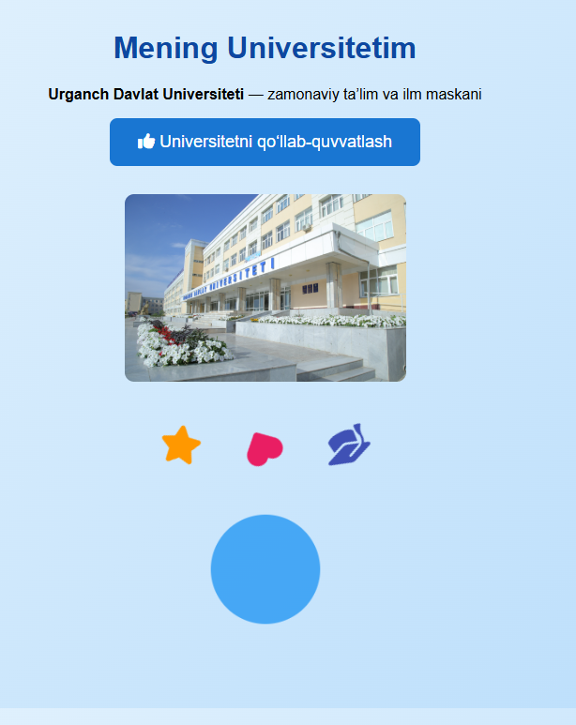

Xulosa:
Ushbu 10-laboratoriya ishida biz CSS transition va animation imkoniyatlaridan foydalanib,
veb sahifadagi elementlarni interaktiv holga keltirishni o‘rgandik. Ish davomida:
- Button (tugma) elementiga hover va click holatlari uchun silliq o‘tish (transition) effektlari berildi,
natijada foydalanuvchi bilan o‘zaro aloqada tugma dinamik ko‘rinish oldi.
- Rasm (img) elementiga o‘lcham va burilish (transform + transition) effektlari qo‘llanilib, vizual joziba yaratildi.
- Ikonkalar (Font Awesome yordamida) turli ranglarda chiqarilib, doimiy harakat (animation) orqali sahifaga jonlilik qo‘shildi.
- Qo‘shimcha “Tashakkur!” stikeri yaratilishi orqali foydalanuvchi harakatiga (bosish) javob qaytaradigan interaktiv element hosil qilindi.
Natijada, foydalanuvchi tajribasini yaxshilovchi, vizual jihatdan boy va zamonaviy dizaynli mini-sayt yaratildi.
Bu laboratoriya ishi CSS orqali dizayn va interaktivlikni uyg‘unlashtirish yo‘llarini amaliy o‘rganish uchun mustahkam asos bo‘lib xizmat qiladi.

